PRESS FILE


- m-Companion: Highly-specific user- and location- dependent information
- The mobile electronic companion : walking instructions up to the front door... and beyond.
- About Web2tel
- About VoiceXML

Contact :

Mr François Manchon
Director
C/o CICA
2229 Route des Crêtes
06560 Sophia Antipolis
France
Tel. : +33 (0)4 92 94 25 23
GSM : +33 (0)6 79 58 48 37
Email : info@web2tel.net
Web: www.web2tel.net

This paper, including illustrations, is available at www.web2tel.net/en/galileo.doc
m-Companion: Highly-specific user- and location- dependent information

m-Companion is an interactive service designed to assist people move around and discover public areas. It provides walking or driving directions as well as user- and location-dependent information. For example: train or airline departure times, restaurant menus, shop promotions, hotel room availability, tourist information.

- The end-user equipment is light and cheap:

- In its simplest form, the user needs to carry nothing but a standard GSM handset. A low-end GSM handset is appropriate, because m-Companion provides information as an audio stream.
- A Galileo or GPS receiver may be added for automatic positioning.
- No database or software license is needed.

- Instructions are highly-specific:

- Information is selected to match to the user preferences: business, travel, shopping, ...
- instructions can be extremely fine-grained, for example depending on which floor and which corridor they are inside a multi-storey building.

Sample applications
- Walking instructions in dense urban areas, or inside buildings.
- User-specific walking instructions and targeted advertisement inside a mall or other shopping area.
- User-specific walking instructions and personalized guidance inside airports, train stations or other complex transportation systems.
- Driving instructions. m-Companion is substantially cheaper than existing automotive navigation systems.
- Driving and walking instructions inside a car park.
- Walking instructions and personalized information for the visually challenged.
Web2tel builds on Web standards, to design next generation Interactive Voice Response (IVR) services.

The mobile electronic companion :

walking instructions up to the front door….and beyond

Have you ever been lost in town, desperately looking for your customer’s building, and nobody at hand to tell you which way to go? Have you ever been walking in a foreign country, without a city map or guide, unable to ask for directions in the local language? Have you ever been looking for a friend’s cottage, wondering why you didn’t purchase that smart navigation system with your new car? If this sounds familiar, there may be a solution coming. Web2tel, a young company from Sophia-Antipolis, located in the French Telecom Valley, is developing an innovative product specially intended to help you.
m-Companion is an interactive service designed to help people move within and discover public areas. It provides walking or driving directions as well as user- and location-dependent information. For example: train or airline departure times, restaurant menus, shop promotions, hotel room availability, or tourist information.
The core of m-Companion is an Interactive Voice Response (IVR) service coupled with a Geographical Information System (GIS). Pick up your cell phone, call m-Companion and ask for directions. The IVR includes state of the art Automatic Speech Recognition (ASR) technology and a database off all known streets, roads, places, parks, corners, and other location names. You say where you are and where you want to go. m-Companion then calculates the best itinerary and tells you the walking instructions using best in class Speech Synthesis.
Don’t even know where you are? All right, you need an extra device: a satellite positioning receiver. Connect it to your cell phone, and m-Companion will use the satellite data to locate you. The complete solution is comparable to a car navigation system, and substantially cheaper.
As of today, you can purchase a Global Positioning System (GPS) receiver from your local electronics dealer. GPS still has some limitations some parts of the globe, such as Northern Europe, dense urban areas, and inside buildings. This limitation will be overcome when Galileo, the European satellite positioning system, is launched. This will open a whole range of new applications, such as traveler guides inside airports, train stations, and museums, or buyer guides inside shopping areas and malls.
Don’t even know where you are going? All right, maybe you should try the visitor’s guide section of m-Companion...

Example: Walking instructions in Munich

Jack comes to Munich by train for a customer meeting. He is standing in front of the railway station, wondering how to reach the meeting place. The customer told him that Karolinenplatz is within walking distance of the railway station, but where?
Jack notices the m-Companion phone number, conveniently displayed nearby the exit of the railway station. He picks up his cell phone, dials the number and the dialog starts as follows:
m-Companion: Welcome to Munich. Where would you like to go?
Jack: mm, I want to go to, er, to Karolinenplatz, please.
At this point, m-Companion’s Automatic Speech Recognition (ASR) system scans Jack’s query, discards the non-significant words and asks for a confirmation:
m-Companion: If you want to go Karolinenplatz, press 1. Otherwise press star.
Jack presses 1 to confirm. Since he does not have a satellite positioning receiver (yet), m-Companion cannot guess his departure point, so the dialog continues:
m-Companion: Where are you at present?
Jack: Well, I’m in front of the railway station.
Again, m-Companion’s ASR scans Jack’s query, discards non-significant words and reformulates the starting point:
m-Companion: If you are on Bahnhofplatz, press 1. Otherwise press star.
Jack presses 1 to confirm. m-Companion calculates the shortest route and the dialog goes on:
m-Companion: The walking distance is 1050 meters. Go ahead on Bahnhofplatz and walk for 190 metres until Luisenstrasse. When you reach Luisenstrasse, press 1. To repeat the instructions, press 2. For a new route, press star.
Jack walks to Luisenstrasse and presses 1.
m-Companion: Go ahead on Luisenstrasse and walk for 60 metres until Sophienstrasse. When you reach Sophienstrasse, press 1. To repeat the instructions, press 2. For a new route, press star.
Jack walks to Sophienstrasse and presses 1.
m-Companion: Turn right on Sophienstrasse and walk for 310 metres until Arcostrasse. When you reach Arcostrasse...
and the process goes on until Jack reaches his destination.
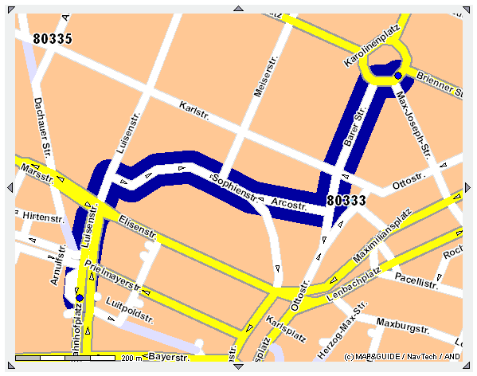
Figure 1 — Jack’s route through Munich, from Banhofplatz to Karolinenplatz (map and route courtesy of PTV Online)

About Web2tel

Web2tel was created in July 2003 to develop next generation Interactive Voice Response (IVR) services. The company’s products are based on the Voice eXtensible Markup Language (VoiceXML), a recent W3C standard.
Web2tel is a spin-off from Lucent Technologies, whose research arm, Bell-Labs, initiated VoiceXML. Lucent Technologies is a founding member of the VoiceXML Forum. Web2tel is a member of this Forum. Web2tel’s founder, François Manchon, features nearly 20 years of experience in R&D, consulting and technical support of advanced telecom products.
Traditional Interactive Voice Response (IVR) servers rely on proprietary technology. VoiceXML technology brings to IVR the benefits of open standards: cost reduction thanks to increased competition, seamless integration with other Web applications, leveraging of Web technologies and tools, and accelerated time to market.
Web2tel’s VoiceXML applications are tailored for:

- Web sites looking for means to reduce user churn, get a competitive advantage, and increase revenues.
- Corporations aiming at cost reduction of their IVR services.
- VoiceXML platform vendors, hosting providers, and network operators who want to extend their value proposition with off-the-shelf VoiceXML applications.

Bringing Web Contents to the Telephone
Most Web sites are accessible only via the Internet. The Internet has several hundred million users worldwide, but there are ten billion telephones on this planet, including more than one billion GSM handsets.
Web2tel provides Web users with one additional channel: they access the same interactive contents over the phone, with complete freedom, quickly, and easily. This is a competitive advantage, a new distribution channel, and a new revenue source for the Web site.

Reducing IVR costs
The development and operating costs of an Interactive Voice Response (IVR) service can be substantially high. Maintenance costs build up quickly, especially when the contents are updated frequently. Web2tel offers to reduce operating costs thanks to VoiceXML benefits

VoiceXML applications wanted
VoiceXML is still a recent technology, and the market is progressively shaping. A tremendous effort was made in the past ten years to develop fully functional and reliable hardware and software platforms. The next step is in applications development. In fact, the VoiceXML Industry today is comparable to the Computer Industry twenty years ago: the platforms are now ready, and end-users are requiring off-the-shelf applications. The market is in need of software editors.

VoiceXML in action
Web2tel’s demo service is available 24x7 at +33 (0)4 34 08 02 17 (in French). It exhibits the following features:
- How Web contents can be distributed over the phone. Call the demo service and select option 1. This application plays airline timetables. The same demo application is available from www.web2tel.net/en/services_demo.html.
- How Web contents can be played in real-time. Go to www.web2tel.net/en/services_demo.html#yourtext, select the language of your choice and type your own text. Then, call the demo service and select option 2. This application uses Speech Synthesis to play the text you just typed.
- How Voice contents can be added to a Web Site. Call the demo service, select option 3, and record your own voice message. When you are done, you can listen to your recorded voice at www.web2tel.net/en/services_demo.html#yourvoice.

A Success Story: Prizee.com’s phone games
Web2tel is the developer and operator of Prizee.com's phone games. Thanks to this service, Prizee.com’s users can play over the phone the same games that they like on the Web site (see Figure 2).
Prizee.com is the largest French speaking free gaming Web Site, with over 2.2 million registered users. As of August 2004, after less than 9 months of operation, this product reached more than one million games played over the phone.
Prizee's phone games are currently available (in French) to registered users calling from France, Belgium or Switzerland. Registration is free (www.prizee.com/inscription.php). The access numbers are the following:
France | 0892 259 433 | (0.34 EUR per minute)
Belgium | 0903 36 240 | (1.12 EUR per minute)
Switzerland | 0901 555 433 | (2.00 CHF per minute)
If you call without being registered, you may use identification number 71-36-89. Please note that this number allows you to play, but you will not be able to claim your earnings.



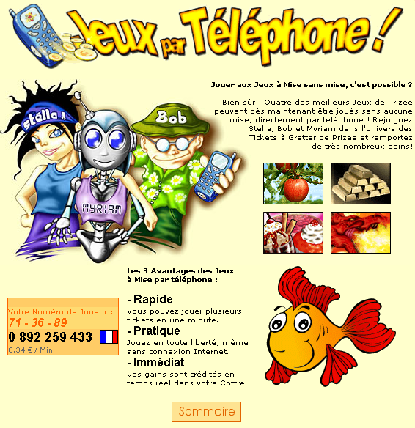
Figure 2 — Prizee.com users can play over the phone a selection of the games that they like on the Web site

About VoiceXML

The Voice eXtensible Markup Language (VoiceXML) is a member of the XML family. It is specifically designed to describe audio user interfaces. Its primary goal is to bring speech applications the methodologies and tools which made the success of the Web. A frequently used analogy is that VoiceXML is to speech applications what HTML is to visual applications.
The main strength of VoiceXML is standardization. A traditional IVR application can function only with its underlying proprietary technology. On the contrary, VoiceXML applications are portable. They can function on the most appropriate servers at each stage of their lifecycle.
A VoiceXML application is made of multiple resources:
- VoiceXML scripts, which define the contents and sequencing of dialogs between the user and the application.
- Pre-recorded audio, which the application plays during the dialogs.
- Text, which the application plays with speech synthesis.
- Speech recognition grammars, that define expected user utterances.
- ECMAscript (JavaScript) resources which make up VoiceXML dynamic capabilities.
Interpretation of those resources by the VoiceXML Gateway lets users access the desired interactive content. They are stored in an application server. They are loaded via HTTP, HTTPS or, optionally, other protocols. They are played by a dedicated server called "VoiceXML Gateway". This is the only server actually connected to the telephone network (see Figure 3).

An Internet standard for the telecom world
A preliminary prototype of VoiceXML, called PML (Phone Markup Language) came to life in 1995 at Bell Labs, the research arm of Lucent Technologies. VoiceXML 2.0 reached the status of a W3C recommendation in March 2004. It is promoted by the VoiceXML Forum, founded by AT&T, IBM, Lucent Technologies and Motorola. Web2tel is a member of this Forum, which gathers more than 300 organizations.

Reference links
- World Wide Web Consortium / Voice Browser Working Group: http://www.w3.org/Voice/
- VoiceXML Forum: http://www.voicexml.org/



VoiceXML benefits
Traditional IVR servers rely on proprietary technology. When an organization decides to outsource voice services to a traditional operator, they become locked-in by the operator's technology. After the service is developed and commissioned, it is very difficult to bring in other operators. In this case, moving to a competing operator is a tough job: it basically means having the application entirely redeveloped.

VoiceXML technology enables substantial cost reductions in development, operations and maintenance for the following reasons:
- Portability enables efficient competition. With VoiceXML, you can select your voice services operator at all times.
- Portability lets you deploy the service as close as possible to the users with no extra cost. VoiceXML Gateway may be located around the world, while the application server remains centralized.
- Speech synthesis and recognition technologies are built-into VoiceXML, which eliminates software integration concerns, and speeds time to market.
- Built-in speech synthesis:
  - Makes information available in real-time, provided the information at stake is readily available in text format. You save the time and cost of human voice recordings, while retaining a good speech quality. For example: News, memos, sports results, stock market data.
  - Lets you create better sounding voice services. It avoids the tricky concatenation of recorded speech chunks, which makes artificially sounding sentences.
  - Lets you create and update services quickly and easily, when recorded speech is inappropriate. For example: Directory lookup, financial data, and real-time transportation timetables.
  - Considerably reduces maintenance costs and schedules, by reducing or eliminating the need to re-record human speech for every service update.
- Speech recognition lets you design more user-friendly IVR services. Instead of tedious touchtone menu selections, users just have to utter their request. For example: For a flight schedule IVR, instead of selecting an airline name, departure airport, and arrival airport, in endless menus, the user just asks “Tell me the arrival times of British Airways flights from London to New-York”.
- VoiceXML relies on Internet standards, which brings a hoard of powerful tools, often at no additional cost.

Figure 3 — VoiceXML reference architecture

Illustrations credits: Ultravertex, Photos.com, Galileo Industries, Microsoft, VoiceXML Forum, Prizee.com, Web2tel.

